ANGLES IN PARALLEL LINES
Pearson Edexcel - Thursday 8 November 2018 - Paper 2 (Calculator) Higher Tier
1.
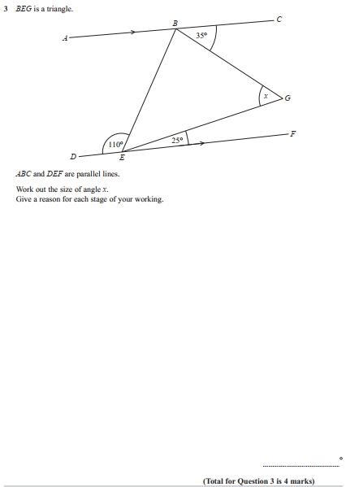
Pearson Edexcel - Thursday 2 November 2017 - Paper 1 (Non-Calculator) Higher Tier
2.
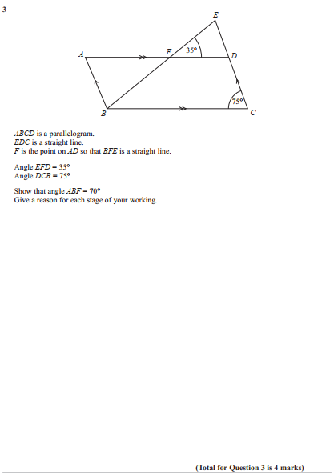
Pearson Edexcel - Sample Paper 1 - (Non-Calculator) Higher Tier
3.
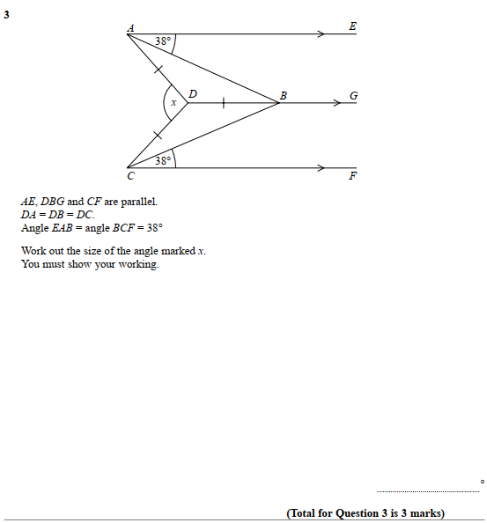

Pearson Edexcel - Thursday 9 June 2016 - Paper 2 (Calculator) Higher Tier
4.
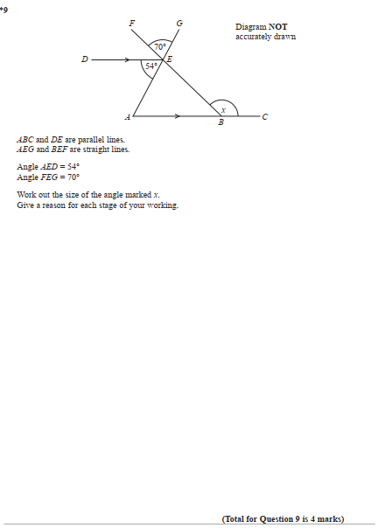

Pearson Edexcel - Wednesday 4 November 2015 - Paper 1 (Non-Calculator) Higher Tier
5.
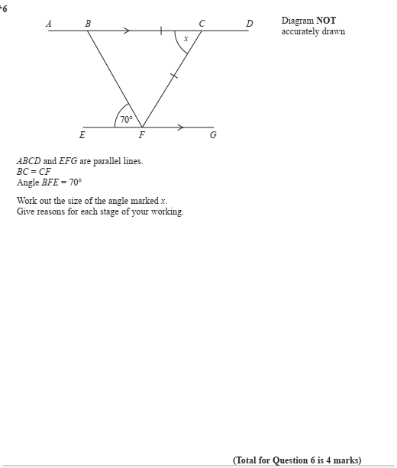

Pearson Edexcel - Thursday 4 June 2015 - Paper 1 (Non-Calculator) Higher Tier
6.
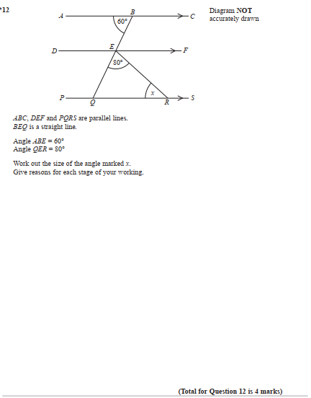

Pearson Edexcel - Wednesday 5 November 2014 - Paper 1 (Non-Calculator) Higher Tier
7.
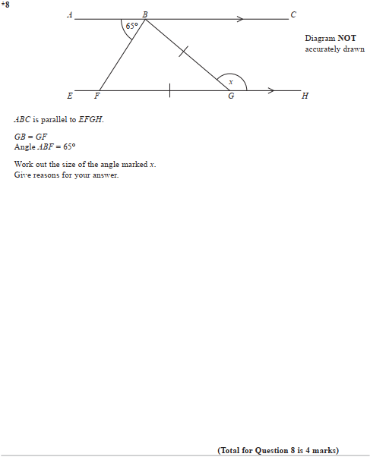

Pearson Edexcel - Friday 13 June 2014 - Paper 2 (Calculator) Higher Tier
8.
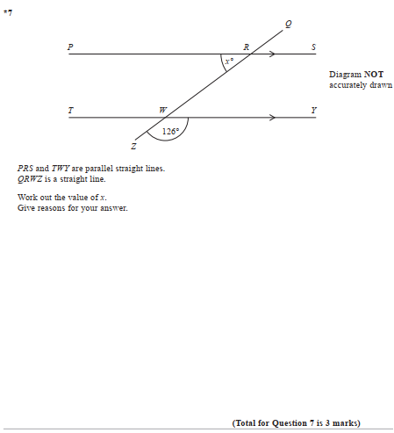

Pearson Edexcel - Friday 14 June 2013 - Paper 2 (Calculator) Higher Tier
9.
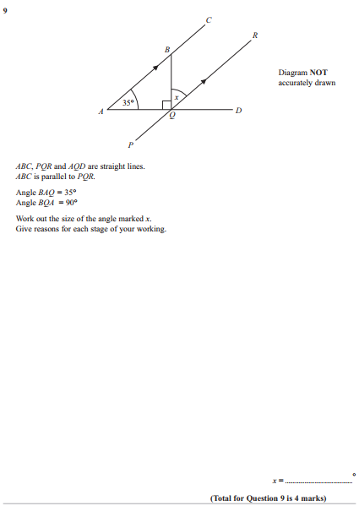

Pearson Edexcel - Thursday 28 February 2013 - Paper 1 (Non-Calculator) Higher Tier
10.
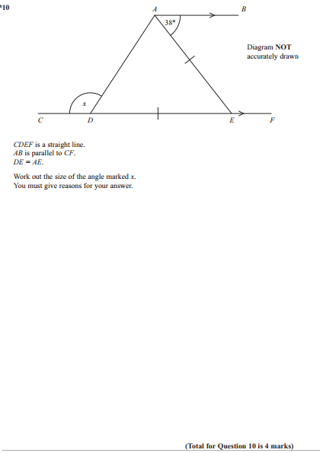

Pearson Edexcel - Thursday 8 November 2012 - Paper 2 (Calculator) Higher Tier
11.
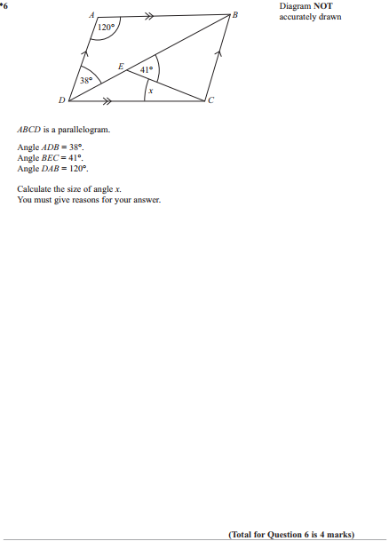

Pearson Edexcel - Monday 11 June 2012 - Paper 1 (Non-Calculator) Higher Tier
12.
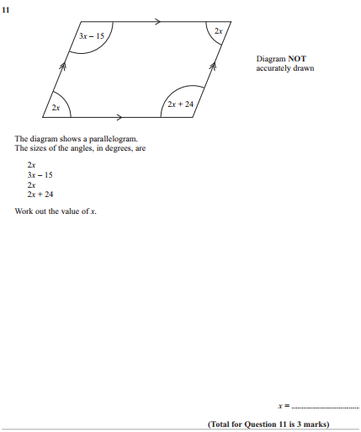

Pearson Edexcel - Wednesday 13 June 2012 - Paper 2 (Calculator) Higher Tier
13.
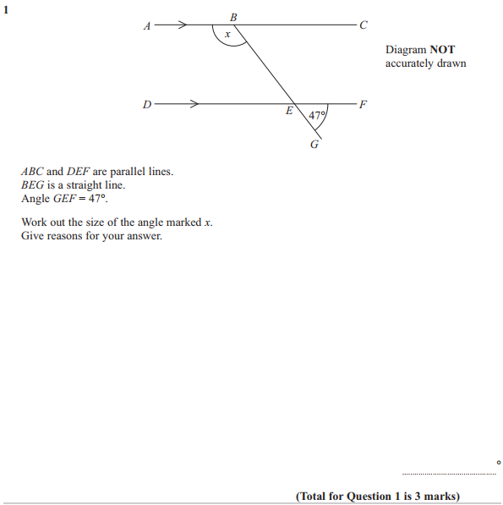

Pearson Edexcel - Friday 2 March 2012 - Paper 3 (Non-Calculator) Higher Tier
14.
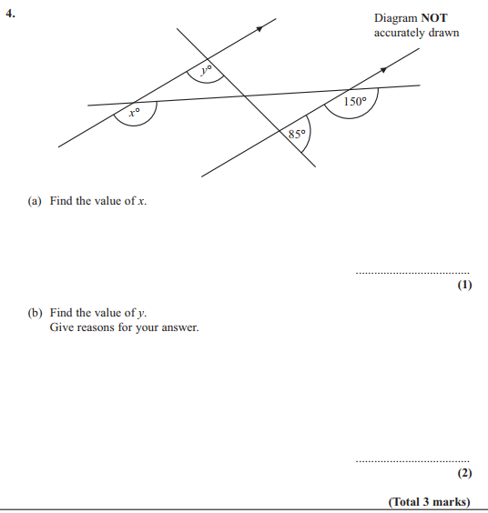

Pearson Edexcel - Monday 6 June 2011 - Paper 3 (Non-Calculator) Higher Tier
15.
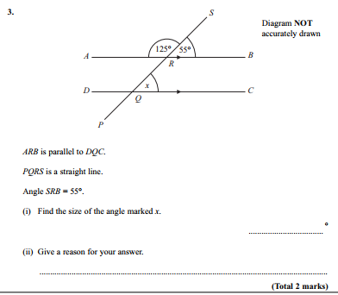

Pearson Edexcel - Friday 11 June 2010 - Paper 4 (Calculator) Higher Tier
16.
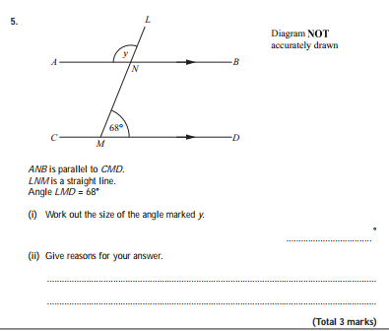
Pearson Edexcel - Tuesday 10 November 2009 - Paper 4 (Calculator) Higher Tier
17.
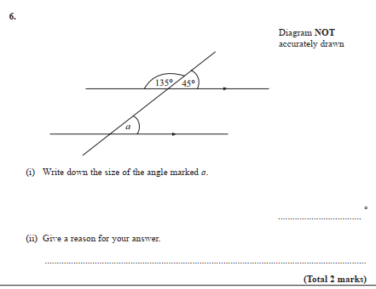
OCR GSCE – Tuesday 21 May 2019 – Paper 4 (Calculator) Higher Tier
18.
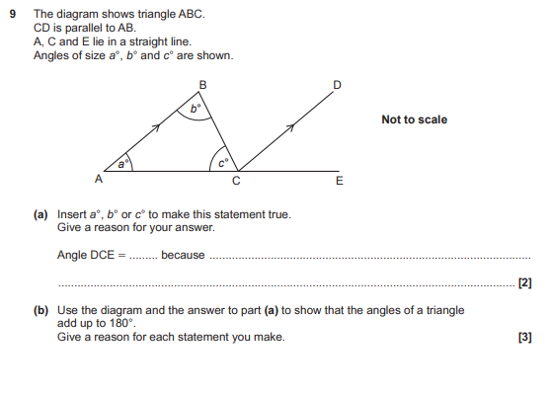
AQA GSCE – Tuesday 13 June 2017 – Paper 3 (Calculator) Higher Tier
19.
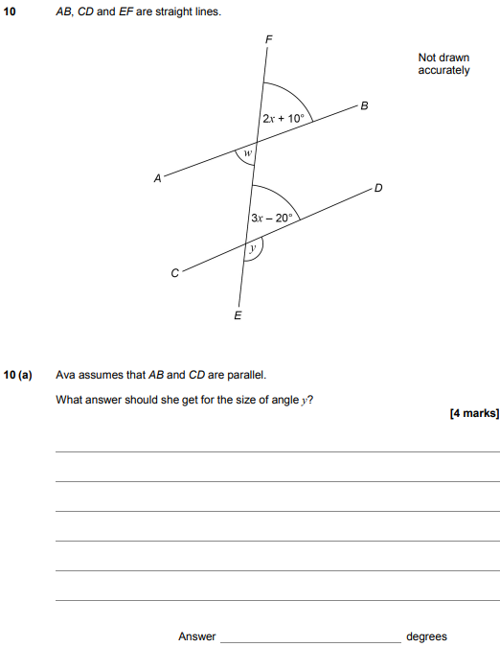
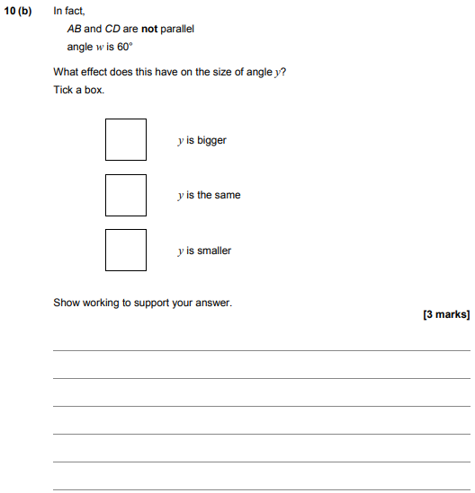

AQA GSCE – Sample Paper 1 (Non - Calculator) Higher Tier
20.
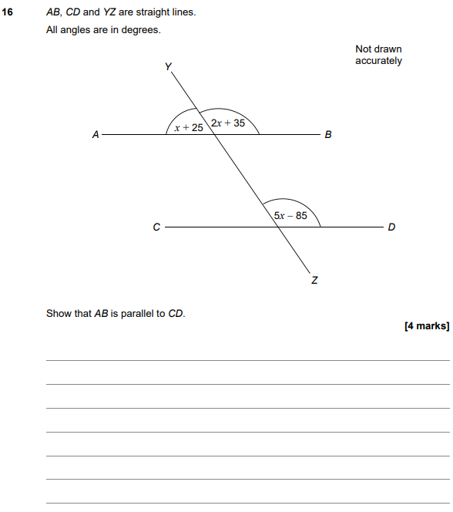

AQA GSCE – Sample Paper 3 (Calculator) Higher Tier
21.
